**Intelligent Agents**

**Agent** – anything that:

* Perceives the environment through sensors.
* Act upon the environment through actuators.

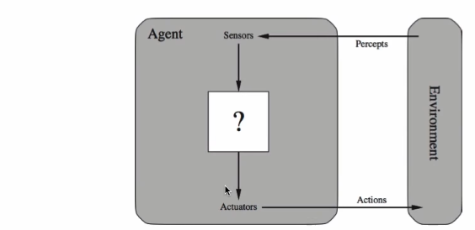

Agent = Architecture (hardware) + Program (software)

**Human:**

Sensors – Eye, ears, organs.

Actuators – Hands, Legs, body parts.

**Robots:**

Sensors: Camera, infrared etc.

Actuators: Motors

**Rationality is related to performance measure**

* Performance measure that defines success
* The agent knows the environment
* The possible action the agent can perform
* The agent percept sequence of date.

**PEAS –** Performance, Environment Actuators and Sensors

**Environment types:**

* Fully Observable – the agent have all the information for the enviorement
* Partially observable – doesn’t have all the information
* Deterministic – actions based upon logic and knowledge
* Stochastic – action based on random choices
* Episodic – works at small or big moments (digital signal structure)
* Sequential – Analog signal structure 1 complete set of actions.

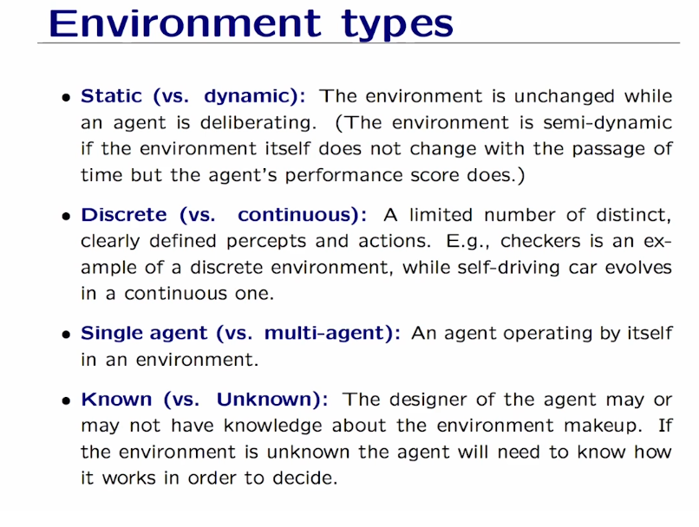

Agents type:

Reflex agents – base on state of action (low intelligente).

Goal based – problem solving (high intelligence).

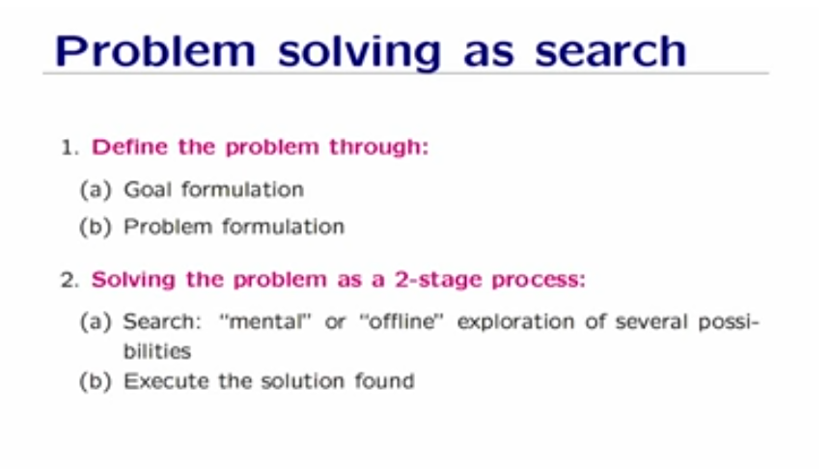

**Problem Formulation:**

* Initial state.
* States (state space).
* Actions (action space) all Actions(s) based on the sate S.
* Transition model: What each action does – Results (s,a).
* Goal test.
* Path cost – performance measure.